**Python Assignment-1**

Q1. In the below elements which of them are values or an expression? eg:- values can be

integer or string and expressions will be mathematical operators.

1. *
2. &#39;hello&#39;
3. -87.8
4. -
5. /
6. +
7. 6

**Sol:**

1. Expression
2. Expression
3. Value
4. Expression
5. Expression
6. Expression
7. Value

Q2. What is the difference between string and variable?

**Sol:** A Variable is a store of information, and a String is a type of information you would store in a Variable.

A String is usually words, enclosed with "" Eg String x ="Welcome to the World" X is the Variable, and we declared it as a String, use the single = to assign the text to it.

Q3. Describe three different data types.

**Sol:**

|  |  |  |
| --- | --- | --- |
| **Data Type** | **Used for** | **Example** |
| Integer | Whole numbers | 7, 12, 999 |
| Character | Encoding text numerically | 97 (in ASCII, 97 is a lower case 'a') |
| Boolean | Representing logical values | TRUE, FALSE |

Q4. What is an expression made up of? What do all expressions do?

**Sol:** An expression is a combination of operators and operands that is interpreted to produce some other value. In any programming language, an expression is evaluated as per the precedence of its operators.

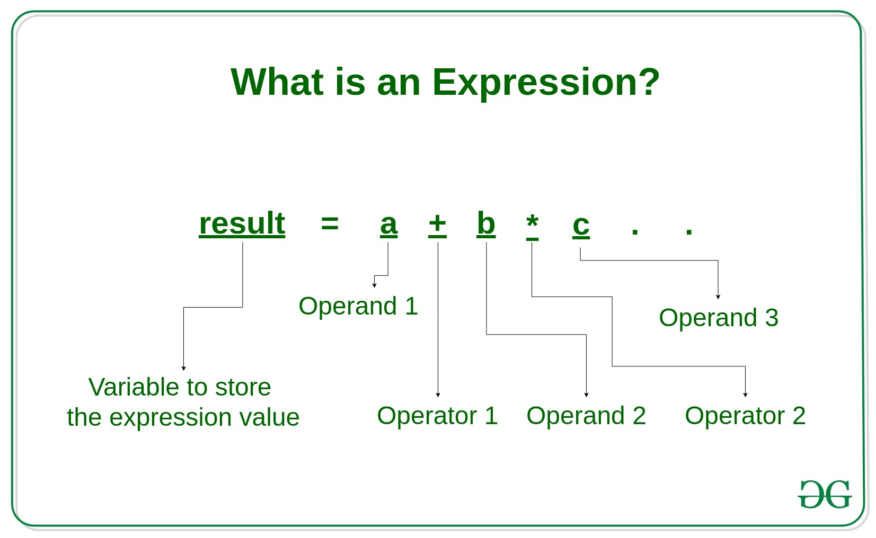

Q5. This assignment statements, like spam = 10. What is the difference between an

expression and a statement?

**Sol:** Assignment statements is used when we assign the value to the variable, here spam is the variable which contains value 10.

Expressions are unique in meaning, while statements are two-sided in execution. For example, 1 has a certain value while go( ) may be executed or not. Statements are the whole structure, while expressions are the building blocks. For example, a line or a block of code is a statement.

Q6. 6. After running the following code, what does the variable bacon contain?

bacon = 22

bacon + 1

**Sol:** bacon = 22

Variable will not increase because it should be (bacon+=1)

Q7. 7. What should the values of the following two terms be?

‘spam’ + ‘spamspam’

‘spam’ * 3

**Sol:** ‘spam’ + ‘spamspam’ :- spamspamspam

‘spam’*3 :- spamspamspam

Q8. Why eggs is a valid variable name while 100 is invalid?

**Sol:** Because variable name cannot start with numeric value.

Q9. What three functions can be used to get the integer, floating-point number, or string

version of a value?

**Sol:** The **int() , float() , and str( )** functions will evaluate to the integer, floating-point number, and string versions of the value passed to them.

Q10. Why does this expression cause an error? How can you fix it?

‘I have eaten’ + 99 + ‘burritos’

**Sol:** Because here we are trying to add two different datatypes that is string and integer.